**ASSIGNMENT – 6**

**SOURCE CODE**

**#include<stdio.h>**

**int main(){**

**printf("enter the data in 2D array\n");**

**int r,c;**

**printf("enter the row of matrix");**

**scanf("%d",r);**

**printf("enter the column of matrix");**

**scanf("%d",c);**

**int arr[r][c];**

**int i,j;**

**for(i=0;i<r;i++){**

**for(j=0;j<c;j++){**

**printf("\n enter number for position [%d][%d] = ",i,j);**

**scanf("%d",&arr[i][j]);**

**}**

**}**

**for(i=0;i<r;i++){**

**for(j=0;j<c;j++){**

**printf("%d\t",arr[i][j]);**

**}**

**printf("\n");**

**}**

**}**

**Output**

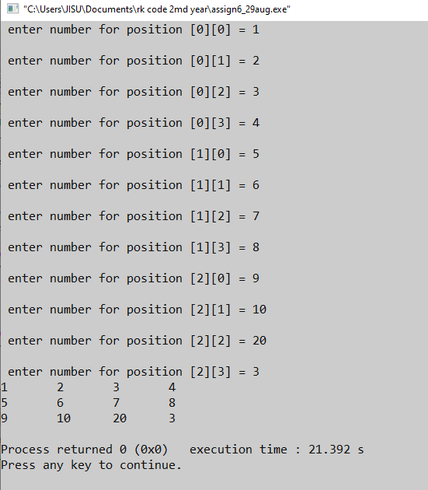

**ASSIGNMENT - 7**

**#include<stdio.h>**

**int main(){**

**printf("enter the data in 2D array\n");**

**int r,c;**

**printf("enter the row of matrix");**

**scanf("%d",&r);**

**printf("enter the column of matrix");**

**scanf("%d",&c);**

**int arr[r][c];**

**int i,j,count=0;**

**for(i=0;i<r;i++){**

**for(j=0;j<c;j++){**

**printf("\n enter number for position [%d][%d] = ",i,j);**

**scanf("%d",&arr[i][j]);**

**if(arr[i][j]==0){**

**count=1+count;**

**}**

**}**

**}**

**for(i=0;i<r;i++){**

**for(j=0;j<c;j++){**

**printf("%d\t",arr[i][j]);**

**}**

**printf("\n");**

**}**

**if(count>r*c/2){**

**printf("this is a sparse matrix");**

**}else**

**{**

**printf("this is not a sparse matrix");**

**}**

**}**

**OUTPUT**

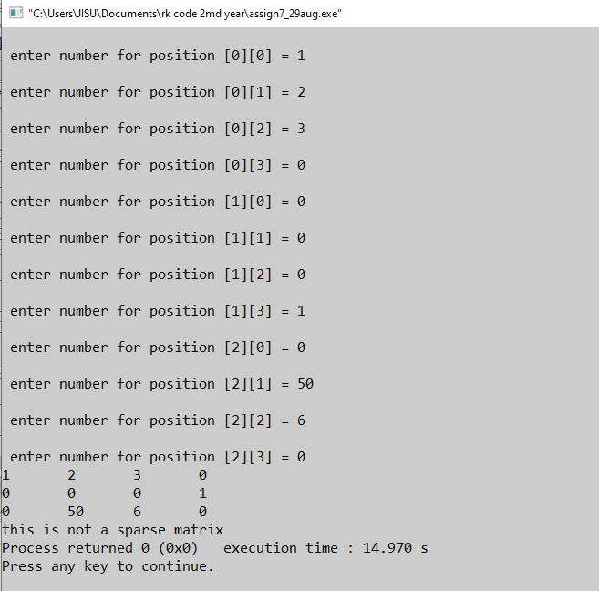

**ASSIGNMENT – 8**

**#include<stdio.h>**

**int main(){**

**printf("enter the data in 2D array\n");**

**int r,c;**

**printf("enter the row of matrix");**

**scanf("%d",&r);**

**printf("enter the column of matrix");**

**scanf("%d",&c);**

**int arr[r][c];**

**int i,j;**

**for(i=0;i<r;i++){**

**for(j=0;j<c;j++){**

**printf("\n enter number for position [%d][%d] = ",i,j);**

**scanf("%d",&arr[i][j]);**

**}**

**}**

**printf("\matrix\n");**

**for(i=0;i<c;i++){**

**for(i=0;i<r;i++){**

**for(j=0;j<c;j++){**

**printf("%d\t",arr[i][j]);**

**}**

**printf("\n");**

**}**

**printf("\n transpose \n");**

**for(i=0;i<c;i++){**

**for(j=0;j<r;j++){**

**printf("%d\t",arr[j][i]);**

**}**

**printf("\n");**

**}**

**}**

**Output**

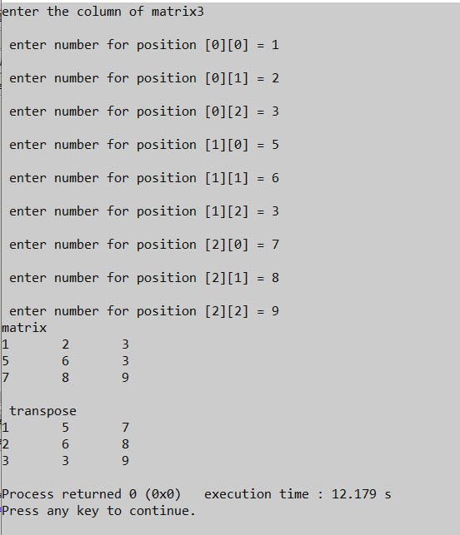

**ASIGNMENT – 9**

**#include<stdio.h>**

**void main(){**

**int s;**

**printf("Enter the size of matrix\t"); //SIZE OF MATRIX DEFINE BY USER**

**scanf("%d",&s);**

**printf("\n");**

**int mat1[s][s]; //DECLARING THE VARABLES OF MATRIX**

**int mat2[s][s];**

**int multi[s][s];**

**int r,c,k,sum; // VARIBLES WHICH WE WILL BE USE FOR LOOP**

**// PUTTING THE VALUES OF THE MATRIX 1 IN ROW AND COLOUMN**

**printf("Enter the no for first matrix\t");**

**printf("\n");**

**for(r=0;r<s;r++){**

**for(c=0;c<s;c++){**

**printf("\nEnter the no\t %d , %d = ",r,c);**

**scanf("%d",&mat1[r][c]);**

**}**

**}**

**printf("\n");**

**// PUTTING THE VALUES OF THE MATRIX 1 IN ROW AND COLOUMN**

**printf("Enter the no for second matrix\t");**

**printf("\n");**

**for(r=0;r<s;r++){**

**for(c=0;c<s;c++){**

**printf("\nEnter the no\t %d , %d = ",r,c);**

**scanf("%d",&mat2[r][c]);**

**}**

**}**

**//Matrix Multiplication**

**for(r=0;r<s;r++){**

**for(c=0;c<s;c++){**

**sum=0;**

**for(k=0;k<s;k++){**

**sum=sum+mat1[r][k]*mat2[k][c];**

**}**

**multi[r][c]=sum;**

**}**

**}**

**printf("**************** FIRST MATRIX ****************\n");**

**for(r=0;r<s;r++){**

**for(c=0;c<s;c++){**

**printf("\t%d\t",mat1[r][c]);**

**}**

**printf("\n");**

**}**

**printf("**************** SECOND MATRIX ****************\n");**

**for(r=0;r<s;r++){**

**for(c=0;c<s;c++){**

**printf("\t%d\t",mat2[r][c]);**

**}**

**printf("\n");**

**}**

**//output**

**printf("***** MULTIPLICATION OF BOTH MATRIX*****\n");**

**for(r=0;r<s;r++){**

**for(c=0;c<s;c++){**

**printf("\t%d\t",multi[r][c]);**

**}**

**printf("\n");**

**}**

**}**

**OUTPUT**

